
FIRST YEAR PROJECT REPORT

SNAKE GAME IN C LANGUAGE

Submitted in partial fulfillment of the degree of Bachelor of Technology

Poornima University

By

Ronak Verma (2020PUSCEBAIX08***)

Academic Year 2020-21 (Odd Semester)
SCHOOL OF COMPUTER SCIENCE & ENGINEERING

Guide: Ms.Monika Goyal



CERTIFICATE

This is to certify that First Year Project Report entitled “SNAKE GAME IN C LANGUAGE” has been submitted by “Ronak Verma (2020PUSCEBAIX08***) for partial fulfillment of the Degree of Bachelor of Technology / Bachelor of Computer Applications of Poornima University. It is found satisfactory and approved for submission.

Date:19/1/2021

Dr./Mr./Ms. Monika Goyal | Dr. Ajay Khunteta
PROJECT GUIDE | DEAN
School of Computer Science & Engineering | School of Computer Science & Engineering


ACKNOWLEDGEMENT

A project of such a vast coverage cannot be realized without help from numerous sources and people in the organization. We are thankful to Dr. Ajay Khunteta, Dean, School of Computer Science & Engineering, Poornima University for providing us a platform to carry out such huge projects successfully.

We are also very grateful to Ms. Monika Goyal Assistant professor, School of Computer Science & Engineering, Poornima University for his/her kind support. He has been a guide, motivator & source of inspiration for us to carry out the necessary proceedings for the project to be completed successfully.

We are thankful to Ms.Aishwarya Upadhyay for her kind support and providing us expertise of the domain to develop the project.

We are also privileged to have Dr.Madan Lal Saini who have flourished us with his/her/their valuable facilities without which this work can not be completed.

We would also like to express our hearts felt appreciation to all of our friends whom direct or indirect suggestions help us to develop this project and to entire team members for their valuable suggestions.

Lastly, thanks to all faculty members of School of Computer Science & Engineering, for their moral support and guidance.

Submitted by: Ronak Verma
EXPLANATION

In this project, a number of questions are asked. In quiz game, questions are chosen in such a way that they cover all topics of DATA STRUCTURE. The user’s knowledge is tested with quiz questions regarding Linked lists, Stacks, Queues, Trees, Graphs and many more.

I have divided this mini project into many functions, and listed below are some of those which may help you understand the project better.
- edit_score() – adds the current cash prize won to the previous one upon giving the
right answer to a question
- help() – help menu with game summary and rules
- reset_score() – to reset the highest score/cash prize to default
- show_record() – shows the highest score won by a particular user
- show_score() – to view the highest score

In this quiz game mini project, you can store the user name, view the highest score secured by a user, and even reset the score. Additionally, to make the game look a little more interesting, it is divided into two rounds; user must pass the first round to reach the second one.

Of the 2 rounds I mentioned above, the first is called the Warm-up Round; the second is the Challenge round. In the warm-up round, the user is asked a total of three simple questions and they must be able to answer at least two of them correctly to enter the next round. If the user is not capable of doing that, he is not permitted to proceed further.

In the second and more interesting round of this quiz game in C, the user will be asked The questions continuously, and for each right answer given, they will earn 1 point.

Game ends when the user’s points. For each question asked, there are 4 options, namely A, B, C and D. There are no negative markings, so the user’s accumulated cash money won’t be deducted for wrong answers to the questions.

FLOW CHART

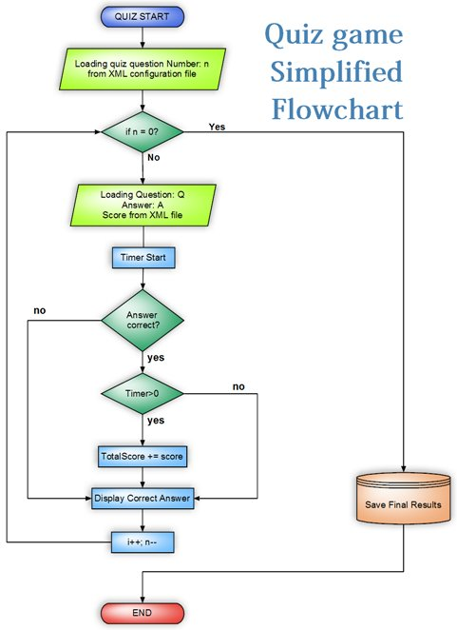

SOURCE CODE

#include<stdio.h>
#include<conio.h>
#include<ctype.h>
#include<stdlib.h>
#include<time.h>
#include<dos.h>

void displayscore()
{
char name[20];
float s;
FILE *f;
system("cls");
f=fopen("score.txt","r");
fscanf(f,"%s%f",&name,&s);
printf("\n\n\t\t ");
printf("\n\n\t\t %s has secured the Highest Score %.2f",name,s);
printf("\n\n\t\t ");
fclose(f);
getch();
}

void help()
{
system("cls");
printf("\n\n\n\tThis game is very easy to play. You'll be asked some general");
printf("\n\n\tDATA STRUCTURE questions and the right answer is to be chosen among");
printf("\n\n\tthe four options provided. Your score will be calculated at the");
printf("\n\n\tend. Remember that the more quicker you give answer the more");
printf("\n\n\tscore you will secure. Your score will be calculated and displayed");
printf("\n\n\tat the end. If you secure highest score, your score");
printf("\n\n\twill be recorded. So BEST OF LUCK.");
}
void writescore(float score, char plnm[20])
{
float sc;
char nm[20];
FILE *f;
system("cls");
f=fopen("score.txt","r");
fscanf(f,"%s%f",&nm,&sc);
if (score>=sc)
{
sc=score;
fclose(f);
f=fopen("score.txt","w");
fprintf(f,"%s\n%.2f",plnm,sc);
fclose(f);
}
}
int main()
{
int countq,countr;
int r,i;
int pa;int nq[6];int w;
float score;
char choice;
char playername[20];
time_t initialtime,finaltime;
system("cls");
//randomize();
mainhome:
system("cls");
puts("\n\t\t WELCOME TO DATA STRUCTURE TEST PROGRAM....\n\n") ;
puts("\n\t\t-------------------------------");
puts("\n\t\t Enter 'S' to start game ");
puts("\n\t\t Enter 'V' to view high score ");
puts("\n\t\t Enter 'H' for help ");
puts("\n\t\t Enter 'Q' to quit ");
printf("\n\t\t-------------------------------\n\n\t\t ");
choice=toupper(getch());
if (choice=='V')
{
displayscore();
goto mainhome;
}
else if (choice=='Q')
exit(1);
else if (choice=='H')
{
help();
getch();
goto mainhome;
}
else if(choice=='S')
{
system("cls");
printf("\n\n\n\t\t\tEnter Your Name...");
printf("\n\t\t\t");
gets(playername);
home:
system("cls");
initialtime=time(NULL);
countq=countr=0;
i=1;
start:
srand ( time(NULL) );
r=rand()%23+1;
nq[i]=r;
for (w=0;w<i;w++)
if (nq[w]==r) goto start;
switch(r)
{
case 1: printf("Which header file should be included to use functions like malloc() and calloc()");
printf("\nA.memory.h\tB.stdlib.h\nC.string.h\tD.dos.h\n");
countq++;
if (toupper(getch())=='B')
{
printf("\n\nCorrect!!!");
countr++;
break;
}
else
{
printf("\n\nWrong!!! The correct answer is B.stdlib.h");
break;
}
case 2: printf("\n\nWhat function should be used to free the memory allocated by calloc()?");
printf("A.dealloc();B.malloc(variable_name,o)C.free();\tD.memalloc(variable_name,o)");
countq++;
if (toupper(getch())=='C')
{
printf("\n\nCorrect!!!");
countr++;
break;
}
else
printf("\n\nWrong!!! The correct answer is C.free();");
break;
case 3: printf("\n\nSpecify the two library functions to dynamically allocate memory?");
printf("A.malloc() and memalloc()B.alloc() and memalloc()C.malloc() and calloc()D.memalloc() and faralloc()");
countq++;
if (toupper(getch())=='C')
{
printf("\n\nCorrect!!!");
countr++;
break;
}
else
{
printf("\n\nWrong!!! The correct answer is C.malloc() and calloc()");
break;
}
case 4: printf("\n\nIf there is any error while opening a file,fopen will return?");
printf("\nA.Nothing\tB.End of file(EOF)\nC.Null\t\tD.Depends on compiler\n");
countq++;
if (toupper(getch())=='C')
{
printf("\n\nCorrect!!!");
countr++;
break;
}
else
{
printf("\n\nWrong!!! The correct answer is C.Null");
break;
}
case 5: printf("\n\n______ Form of access is used to add and remove nodes from a queue.");
printf("\nA.Last In First Out\tB.First In First Out\nC.Both a and b\t\tD.None of these\n");
countq++;
if (toupper(getch())=='B')
{
printf("\n\nCorrect!!!");
countr++;
break;
}
else
{
printf("\n\nWrong!!! The correct answer is B.First In First Out");
break;
}
case 6: printf("\n\nIn Linked representation of STACK ____ holds the elements of the stack.");
printf("\nA.INFO fields\tB.TOP fields\nC.LINK fields\tD.NULL fields\n");
countq++;
if (toupper(getch())=='A')
{
printf("\n\nCorrect!!!");
countr++;
break;
}
else
{
printf("\n\nWrong!!! The correct answer is A.INFO fields");
break;
}
case 7: printf("the linked representation of the stack _____ behaves as the top pointer variable of stack.");
printf("\nA.Stop pointer\tB.Begin pointer\nC.start pointer\tD.Avail pointer\n");
countq++;
if (toupper(getch())=='C')
{
printf("\n\nCorrect!!!");
countr++;
break;
}
else
{
printf("\n\nWrong!!! The correct answer is C.Start pointer");
break;
}
case 8: printf("\n\nNew nodes are added to the _____ of the queue.");
printf("\nA.Front\t\tB.Back\nC.Middle\tD.Both a and b\n");
countq++;
if (toupper(getch())=='B')
{
printf("\n\nCorrect!!!");
countr++;
break;
}
else
{
printf("\n\nWrong!!! The correct answer is B.Back");
break;
}
case 9: printf("Linked representation of stack the null pointer of the last node in the list signals”);
printf("A.Beginning of the stack.B.Bottom of the stackC.Middle of the stackD.In between some value");
countq++;
if (toupper(getch())=='B')
{
printf("\n\nCorrect!!!");
countr++;
break;
}
else
{
printf("\n\nWrong!!! The correct answer is B.Bottom of the stack");
break;
}
case 10:printf("\n\nA queue is a _________");
printf("\nA.FIFO\tB.LIFO\nC.FILO\tD.LOFI\n");
countq++;
if (toupper(getch())=='A')
{
printf("\n\nCorrect!!!");
countr++;
break;
}
else
{
printf("\n\nWrong!!! The correct answer is A.FIFO");
break;
}
case 11:printf("\n\nWhich of the following name doesn't relate to stacks?");
printf("\nA.FIFO lists\tB.LIFO lists\nC.Piles\t\tD.Push down lists\n");
countq++;
if (toupper(getch())=='A')
{
printf("\n\nCorrect!!!");
countr++;
break;
}
else
{
printf("\n\nWrong!!! The correct answer is A.FIFO lists");
break;
}
case 12:printf("\n\nThe retrieval of items in a stack is _____ operation.");
printf("\nA.Push\t\tB.Pop\nC.retrieval\tD.Access\n");
countq++;
if (toupper(getch())=='B')
{
printf("\n\nCorrect!!!");
countr++;
break;

}
else
{
printf("\n\nWrong!!! The correct answer is B.Pop");
break;
}
case 13:printf("\n\nThe term push and pop is related to ");
printf("\nA.Array\t\tB.Lists\nC.Stacks\tD.Trees\n");
countq++;
if (toupper(getch())=='C')
{
printf("\n\nCorrect!!!");
countr++;
break;
}
else
{
printf("\n\nWrong!!! The correct answer is C.Stacks");
break;
}
case 14:printf("\n\nWhich is the pointer associated with the stack?");
printf("\nA.First\tB.Front\nC.Top\tD.Rear\n");
countq++;
if (toupper(getch())=='C')
{
printf("\n\nCorrect!!!");
countr++;
break;
}
else
{
printf("\n\nWrong!!! The correct answer is C.Top");
break;
}
case 15:printf("\n\nThe elements are removed from a stack in _______ order.");
printf("\nA.Reverse\tB.Hiererchical\nC.Alternative\tD.Sequencial\n");
countq++;
if (toupper(getch())=='A')
{
printf("\n\nCorrect!!!");
countr++;
break;
}
else
{
printf("\n\nWrong!!! The correct answer is A.Reverse");
break;
}
case 16:printf("\n\nThe insertion operation in the stack is called ____");
printf("\nA.Insert\tB.Push\nC.Pop\t\tD.Top\n");
countq++;
if (toupper(getch())=='B')
{
printf("\n\nCorrect!!!");
countr++;
break;
}
else
{
printf("\n\nWrong!!! The correct answer is B.Push");
break;
}
case 17:printf("\n\n_______ is the term used to insert an element into stack.");
printf("\nA.Push\tB.Pull\nC.Pop\tD.Pump\n");
countq++;
if (toupper(getch())=='A')
{
printf("\n\nCorrect!!!");
countr++;
break;
}
else
{
printf("\n\nWrong!!! The correct answer is A.Push");
break;
}
case 18:printf("\n\n_______ is the term used to delete an element from the stack.");
printf("\nA.Push\tB.Pull\nC.Pop\tD.Pump\n");
countq++;
if (toupper(getch())=='C')
{
printf("\n\nCorrect!!!");
countr++;
break;
}
else
{
printf("\n\nWrong!!! The correct answer is C.Pop");
break;
}
case 19:printf("\n\nDeletion operation is done using _____ in a queue");
printf("\nA.Front\tB.Rear\nC.Top\tD.List\n");
countq++;
if (toupper(getch())=='A')
{
printf("\n\nCorrect!!!");
countr++;
break;
}
else
{
printf("\n\nWrong!!! The correct answer is A.Front");
break;
}
case 20:printf("A pointer variable which contains the location at the top element of the stack is”);
printf("\nA.Top\tB.Last\nC.Final\tD.End\n");
countq++;
if (toupper(getch())=='A')
{
printf("\n\nCorrect!!!");
countr++;
break;
}
else
{
printf("\n\nWrong!!! The correct answer is A.Top");
break;
}
case 21:printf("\n\nThe operation of processing each element in the list is known as");
printf("\nA.Sorting\tB.Merging\nC.Inserting\tD.Traversal\n");
countq++;
if (toupper(getch())=='D')
{
printf("\n\nCorrect!!!");
countr++;
break;
}
else
{
printf("\n\nWrong!!! The correct answer is D.Traversal");
break;
}
case 22:printf("\n\nother name for directed graph is ");
printf("\nA.Direct graph\tB.Diagraph\nC.Dir-graph\tD.Digraph\n");
countq++;
if (toupper(getch())=='D')
{
printf("\n\nCorrect!!!");
countr++;
break;
}
else
{
printf("\n\nWrong!!! The correct answer is D.Digraph");
break;
}
case 23:printf("\n\nBinary trees with threads are called as");
printf("\nA.Threaded trees\tB.pointer trees\nC.Special trees\t\tD.Special pointer trees\n");
countq++;
if (toupper(getch())=='A')
{
printf("\n\nCorrect!!!");
countr++;
break;
}
else
{
printf("\n\nWrong!!! The correct answer is A.Threaded trees");
break;
}
}
i++;
if (i<=5) goto start;
finaltime=time(NULL);
score=(float)countr/countq*100-difftime(finaltime,initialtime)/3;
if (score<0) score=0;
printf("\n\n\nYour Score: %.2f",score);
if (score==100) printf("\n\nEXCELLENT!!! KEEP IT UP");
else if (score>=80 && score<100) printf("\n\nVERY GOOD!!");
else if (score>=60 &&score<80) printf("\n\nGOOD! BUT YOU NEED TO KNOW MORE.");
else if (score>=40 && score<60) printf("SATISFACTORY RESULT, BUT THIS MUCH IS NOT SUFFICIENT.");
else printf("\n\nYOU ARE VERY POOR IN DATA STRUCTURE,WORK HARD");
puts("\n\nNEXT PLAY?(Y/N)");
if (toupper(getch())=='Y')
goto home;
else
{
writescore(score,playername);
goto mainhome;
}
}
else
{
printf("\n\n\t\t Enter the right key\n\n\t\t ");
goto mainhome;
}
return 0;
}

OUTPUT

WELCOME SCREEN:
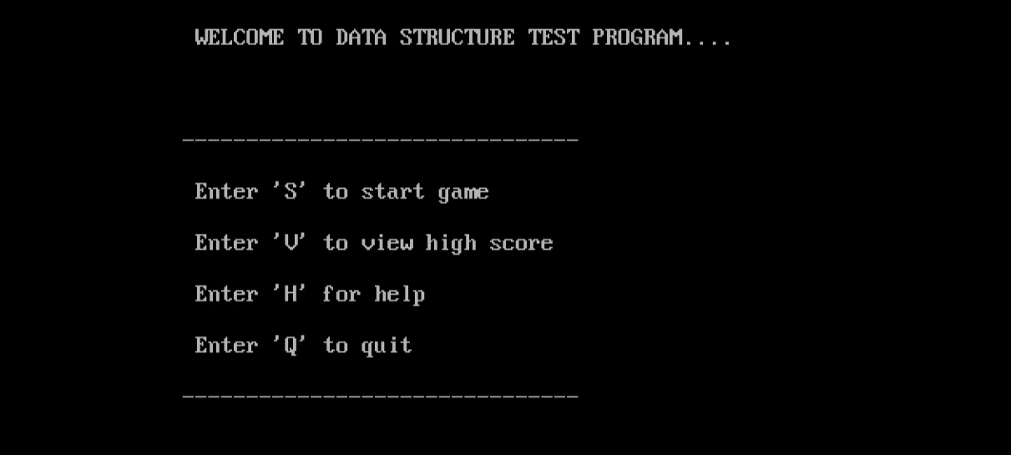

After entering third option ‘H’:
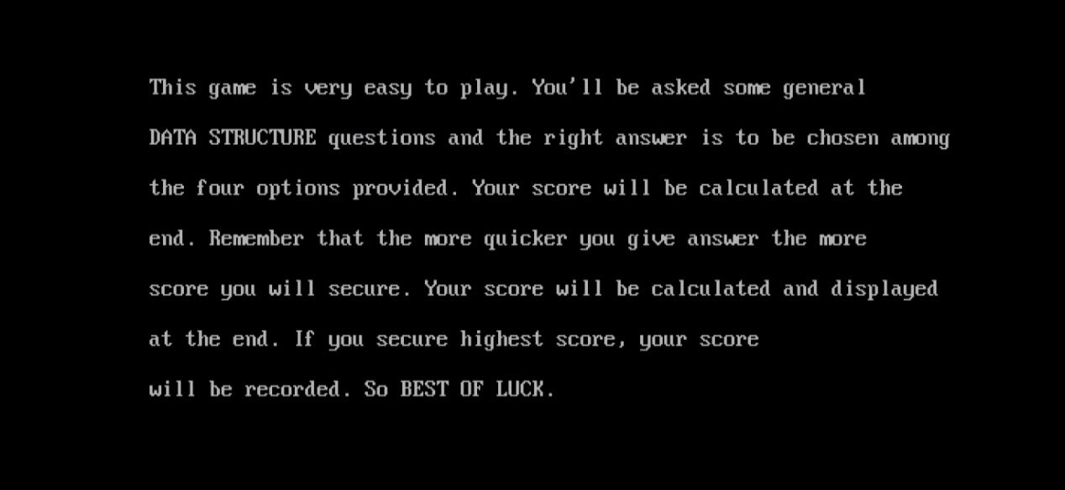

After entering first option ‘S’:
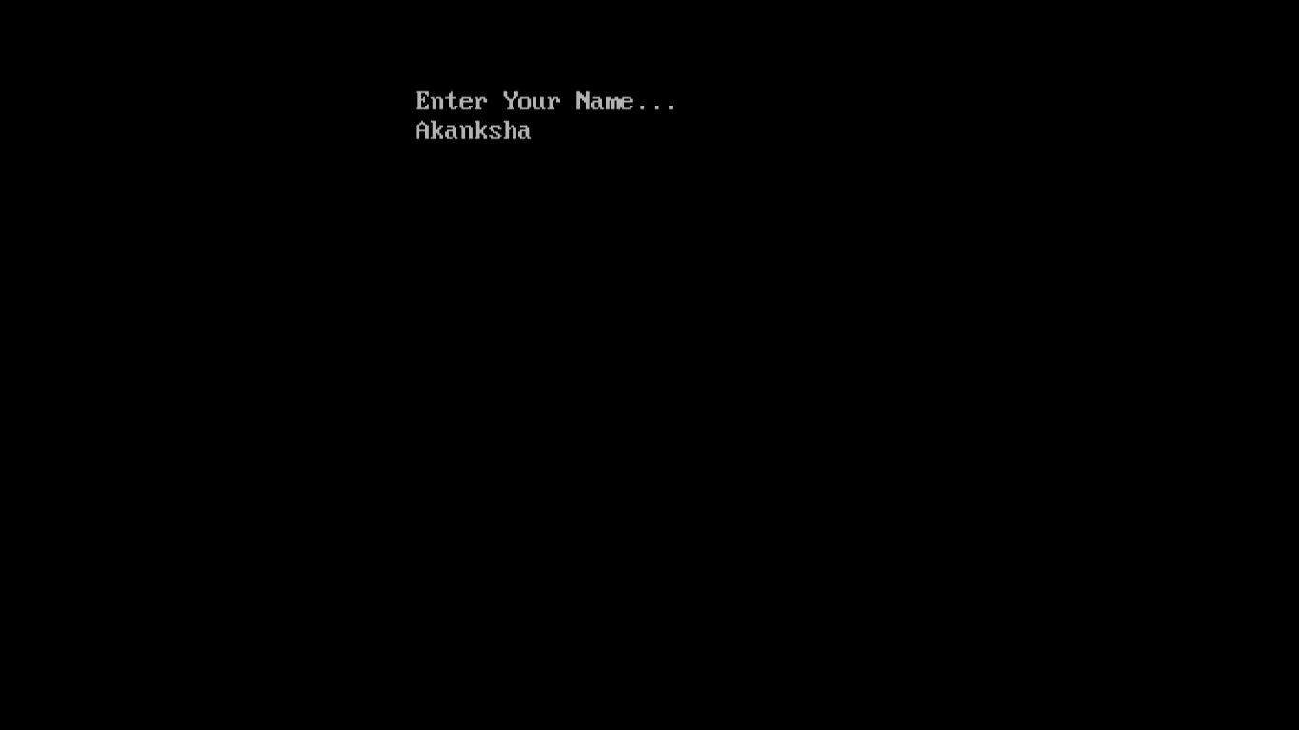

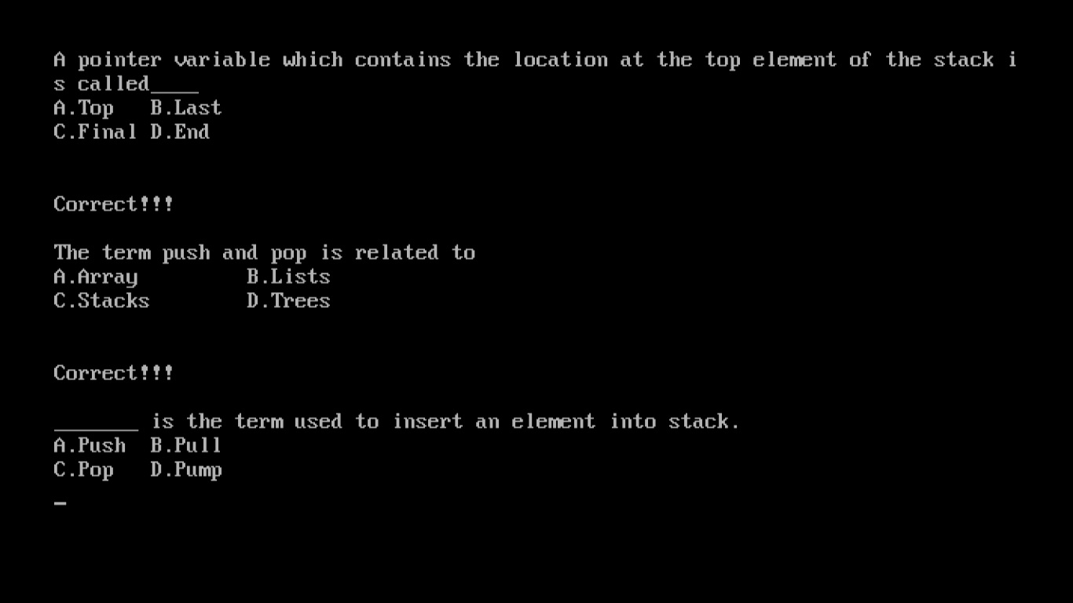

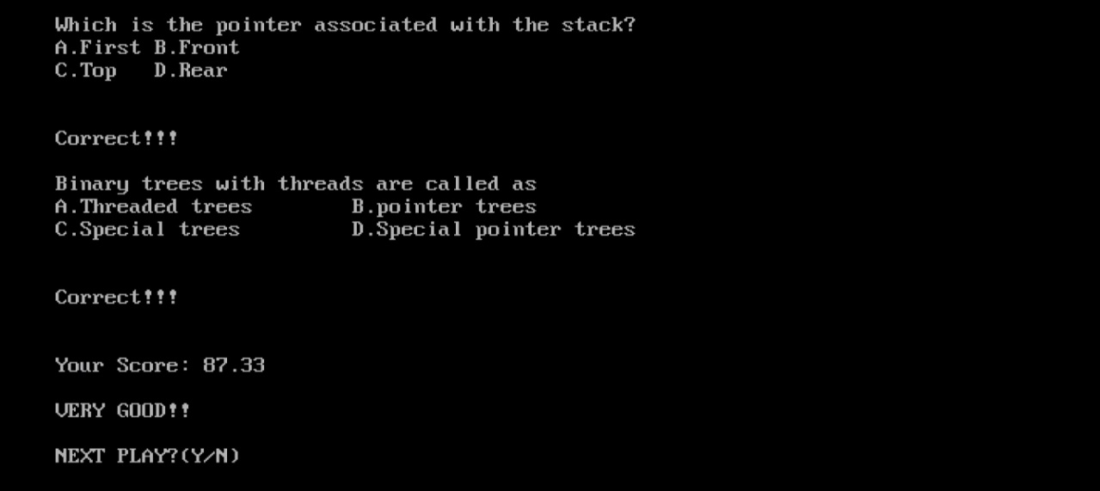

After entering second option ‘V’:
